A   
PROJECT REPORT ON

ONLINE SHOPPING STORE

DESIGNED AND DEVELOPED   
BY   
Mr. Tanmay Prashant Chavan

AND   
GUIDED BY

**Prof. Neelam Tandel**

**SUBMITTED IN PARTIAL FULFILLMENT OF ACADEMIC PROJECT   
  
BACHELOR OF SCIENCE [COMPUTER SCIENCE]**

**[UNIVERSITY OF MUMBAI]**

ACKNOWLEDGEMENT

**ACKNOWLEDGEMENT**

Achievement is finding out what you would be doing rather than what you have to do. It is not until you undertake such a project that you realize how much effort and hard work it is, what are your capabilities, and how well you can present yourself or other things. It tells us how much we rely on the efforts and goodwill of others. It gives me immense pleasure to present this report towards the fulfillment of my project.   
  
  
  
It has been rightly said that we are built on the shoulder of others.   
For everything I have achieved, the credit goes to all those who had   
helped me to complete this project successfully.   
  
  
  
I take this opportunity to express my profound gratitude to   
management of **Royal College of Arts, Commerce & Science** for   
giving me this opportunity to accomplish this project work.   
  
  
  
A special vote of thanks to **Prof. Neelam Tandel**who is   
our professor & project guide for her most sincere, useful and   
encouraging contribution throughout the project span.   
  
  
  
Finally, I would like to thank the entire Computer Science department   
who directly or indirectly helped me in the completion of this project & to   
my family without whose support, motivation & encouragement this   
would not have been possible.   
  
  
 TANMAY PRASHANT CHAVAN

DECLARATION

**DECLARATION**   
  
  
  
I “**Mr. TANMAY PRASHANT CHAVAN** “ hereby declare that I have completed the project under the guidance of **Prof.NeelamTandel**. I on my own have designed the system and have done all the programming required.   
  
  
  
It may require some modifications in the future as per the user’srequirements. From the practical implementation point of viewflexibility in the changes hasbeen incorporated in the package.   
  
  
I am sure that I can do any kind of modification suggested while practical implementation by modifying the file design or the programcode if necessary.   
  
  
  
  
  
 **Tanmay Prashant Chavan**

CERTIFICATE



**DEPARTMENT OF COMPUTER SCIENCE**

Class: TYBScRoll. No. 07   
Seat No:_______  
**Certificate**  
  
Certified that Ms. Anam Khan of T.Y.B. Sc Semester VI has completed the project as prescribed by the University of Mumbai on ONLINE SHOPPING STORE as partial fulfillment of the requirement for completing Bachelor’s Degree in Computer Science during the academic year 2019-2020.

Signature of Project Guide   
Date: ________________   
  
  
Signature of Examiner   
Date: ______________

HEAD   
Dept. of Computer Science

ABOUT THE   
PROJECT

**Objectives**

The year 2020 has been a roller coaster ride so far. The continuous disasters, the spread of novel coronavirus, altogether, have created havoc among the people. The need for e-commerce has become more than essential now. People now know the importance as well as the benefits of online eCommerce. It has become a part of our daily lives. More and more people now order food, clothes, groceries, home appliances, and much moreonline,using eCommerce.

**Reduce management costs:** Businesses aim at reducing the costs incurred for the betterment of their revenue. Automating the e-commerce business can help in reducing the management cost significantly. Moreover, the right use of digital marketing can help in reducing the cost spent on driving customers to such an extent that businesses can bring customers free of cost.

**Developing business relations:-**With eCommerce as the primary use, business development can be easily achieved. The direct communication between a company and the customer, the business relationship can be boosted.

### Providing a unique customer experience:- Uncountable e-commerce businesses are functioning out there in the market. When a customer searches for a certain product (for instance, shampoo), they will probably click on the first three links that are shown on the Google Search Engine Results Page. All the rest links are either avoided, never seen, or are visited by a few. This itself shows the competition in the e-commerce market. One of the best ways to stand out from the crowd is by providing a unique customer experience. This includes giving a personalized experience to each customer or visitor of your online store, website, or mobile app

### Increasing the number of loyal customers:- Customers are the core of all business strategies. Therefore, ensuring a great customer experience is of prime importance for the growth of the business. You need to meet your customers where they spend their time. More than 60% of consumers look for purchasing goods and services online. If you meet your customers where they are already active, the chances of them, interacting with your business increases two folds. You can increase the number of loyal customers by giving the best experience to your already existing customers as well as bring in newer customers.

**INDEX**

|  |  |  |
| --- | --- | --- |
| **Sr. No.** | **Topic** | **Page No.** |
| **I.** | **Preliminary Investigation** | **12** |
| 1. | Introduction | 13 |
| 2. | Proposed System and its advantages | 13 |
| 3. | System Requirements | 14 |
| 4. | Phase Title |  |
| 5. | Gantt Chart |  |
| **II.** | **System Analysis** |  |
| 1. | Event Table |  |
| 2. | Use Case Diagram |  |
| 3. | ERD |  |
| 4. | Class Diagram |  |
| **III.** | **System Design** |  |
| 1. | Sequence Diagram |  |
| **IV.** | **System Coding** |  |
| 1. | System Coding |  |
| 2. | Form Layouts |  |
| 3. | Report Layouts |  |
| **V.** | **Future Enhancements** |  |
| **VI.** | **Reference and Bibliography** |  |

**Preliminary Investigation**

**Introduction:*Super Mart*** website is built keeping end-users and owner’s benefits in mind, providing all possible features and options for both, owner as well as the user. It is having features like booking and buying, where users can book the item in store for one month so that it won’t be sold.It helps when the products are less in quantity and if any customer stays far away from the shop and is afraid of losing that product. This website is built for the local but quite big shopwhere you will come across various categories of products like stationery, electronics, toys, sports, etc. in one shop.It helps the users to just sit at home and buy or book any particular product with just a few clicks, which is very helpful in pandemic conditions like the novel corona. Its free delivery system is only available in a specific area as it is not a big shop, but planning to increase the area in future.

**Proposed System and its advantages:**

* User's data is protected and stored in a very robust and reliable firestore database.
* Users need to login/ register and add their area code to book or buy any product.
* It provides very clean and easy-to-understand user settings, with various other feathers.
* It is having a very easy password, username as well as email update system, with very powerful algorithms to prevent clashing with other user's credentials.
* A small guide is provided everywhere, to ensure that users are fully aware of what they are doing.
* It also reduces the workload for the owner to manage and organize products.
* Its master user settings arefilledwith rich features like adding a new product to shop within just a few clicks, removing any product if it is not present in a shop, etc.

**System Requirements:**

* Hardware Requirements:-
* The system with Linux or windows
* Memory with minimum 2GB ram
* Internal with minimum 1GB storage
* System Requirements:-
* Internet connectivity compulsory
* Any basic browser required like Chrome, Firefox, Opera, etc.

|  |  |  |  |
| --- | --- | --- | --- |
| **Phase Title** | **Expected Date of Completion** | **Actual Time of Completion with Guide’s Signature** | **Remarks** |
| **I. Preliminary Investigation** |  |  |  |
| (i) Introduction |  |  |  |
| (ii) Proposed System and its advantages |  |  |  |
| (iii) System Requirements | **28/07/202** |  |  |
| (iv)Phase Title |  |  |  |
| (v) Gantt Chart |  |  |  |
| **II. System Analysis** |  |  |  |
| (i) Event Table |  |  |  |
| (ii) Use Case Diagram | **11/08/2021** |  |  |
| (iii) ERD |  |  |  |
| (iv) Class Diagram |  |  |  |
| **III. System Design** |  |  |  |
| (i) Sequence Diagram | **30/08/2021** |  |  |
| **IV. System Coding** |  |  |  |
| (i) System Coding | **29/09/2021** |  |  |
| (ii) Form Layouts |  |  |  |
| (iii) Report Layouts |  |  |  |
| **V. Future Enhancements** |  |  |  |
| **VI. Reference and Bibliography** |  |  |  |

Gant chart remaining

**II)SYSTEM ANALYSIS**

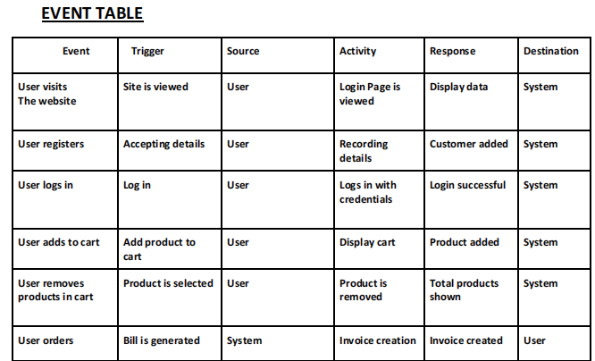

**UML Use Case Diagram:**

**Entity Relationship Diagram(ERD):**

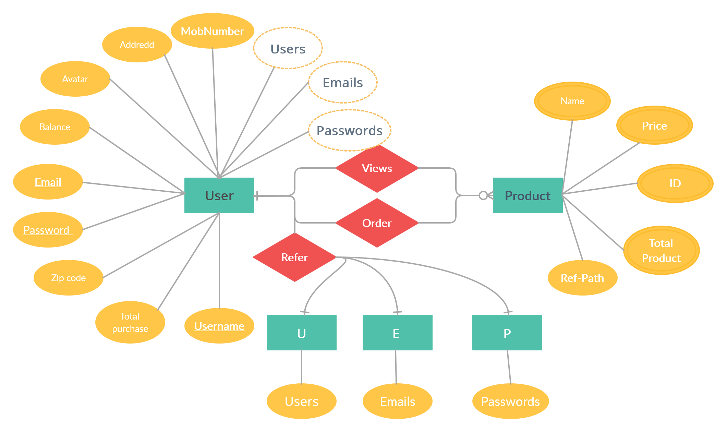

**III)SYSTEM DESIGN**

Sequence Diagram remaining

**IV)SYSTEM CODING**

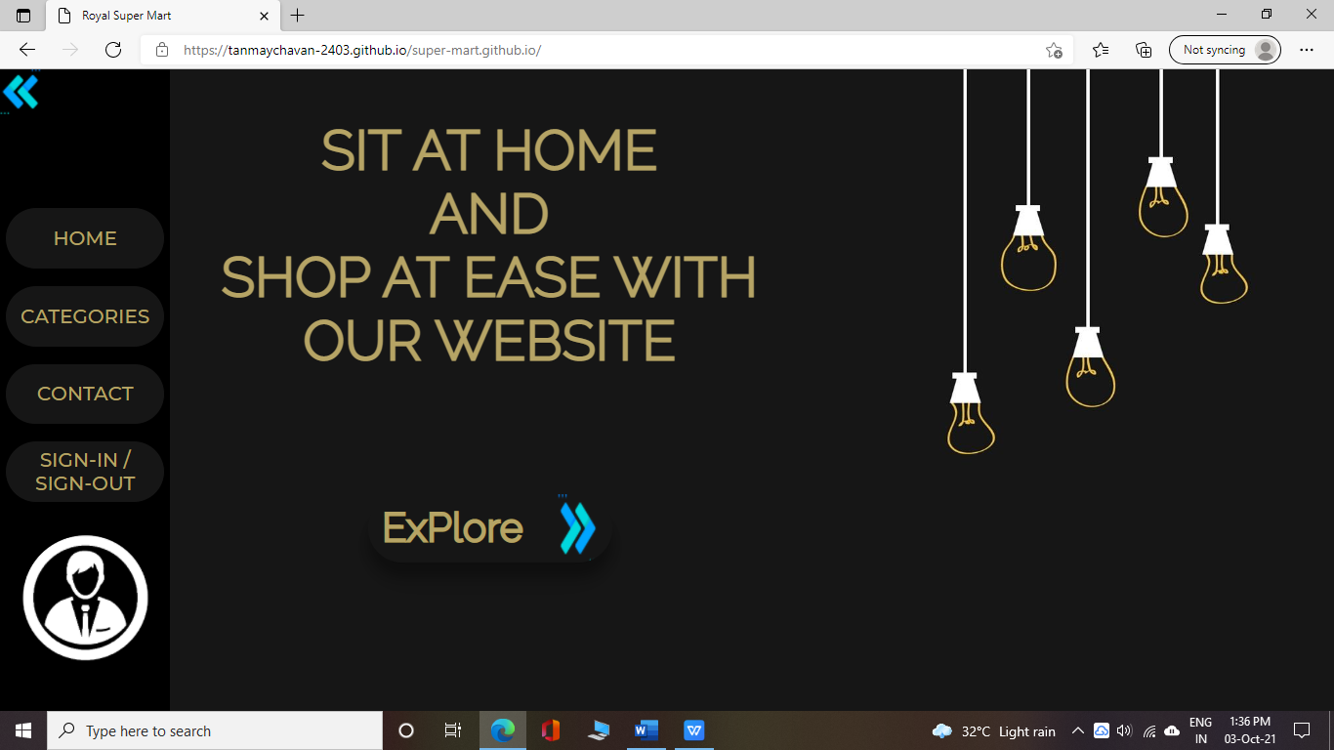

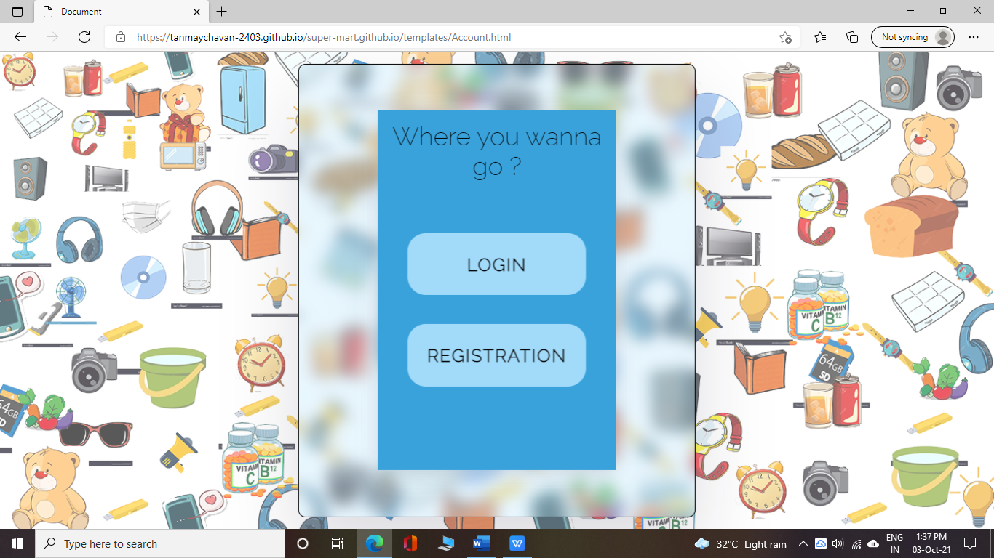

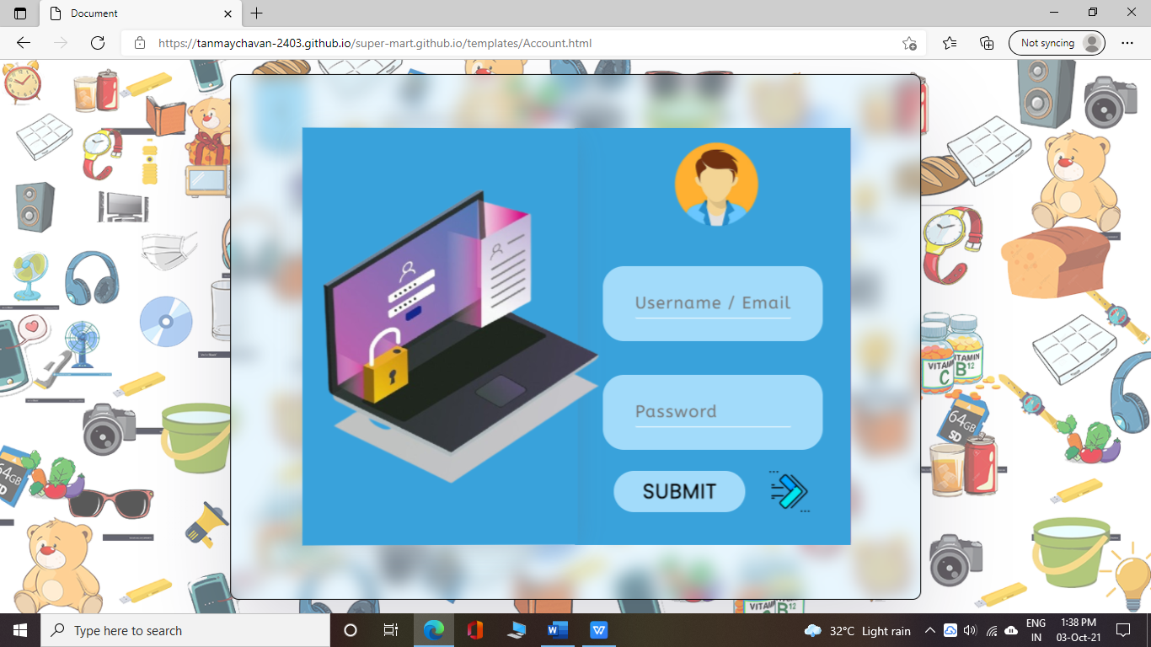

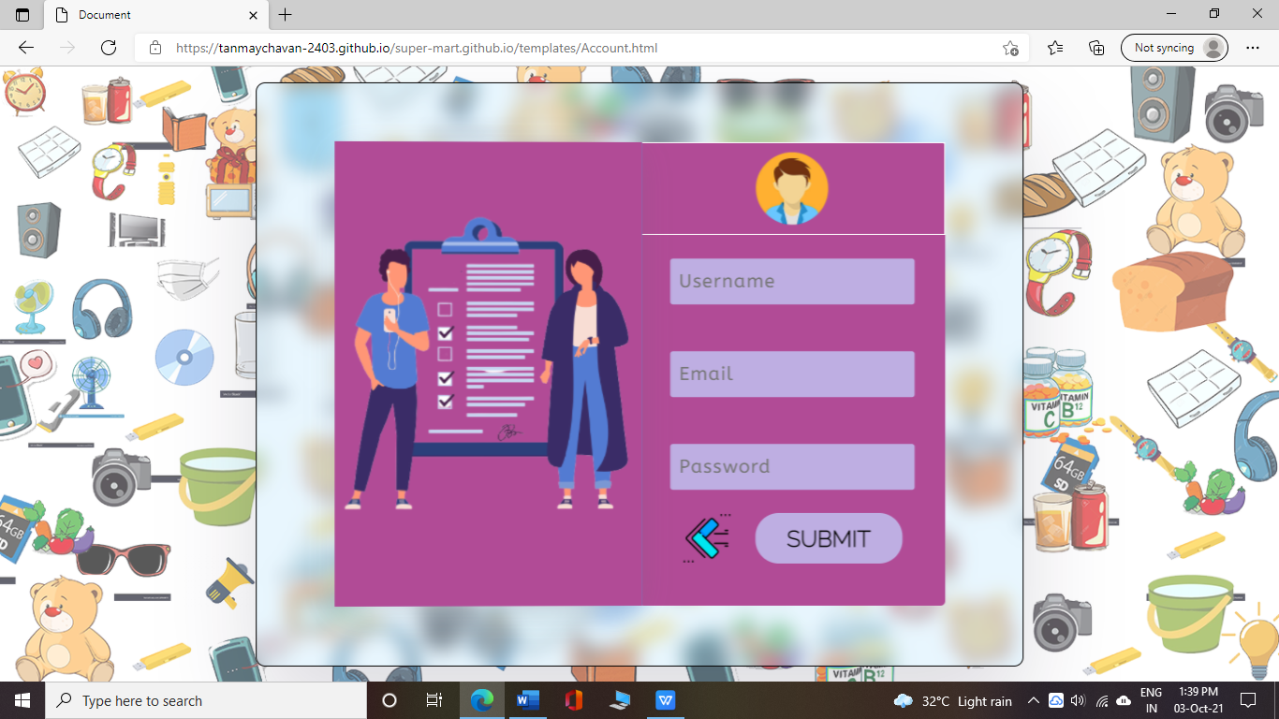

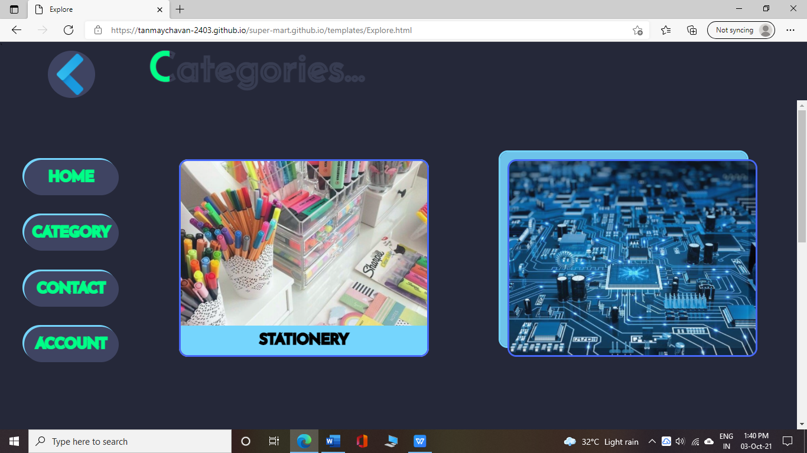

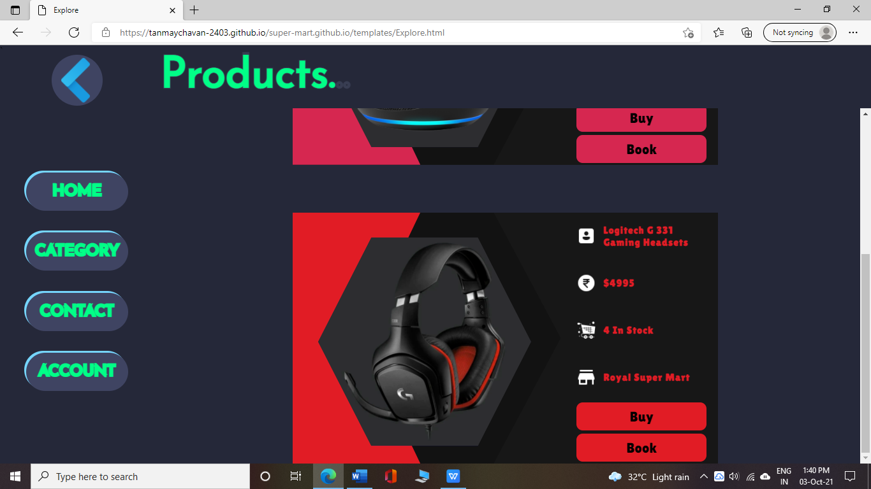

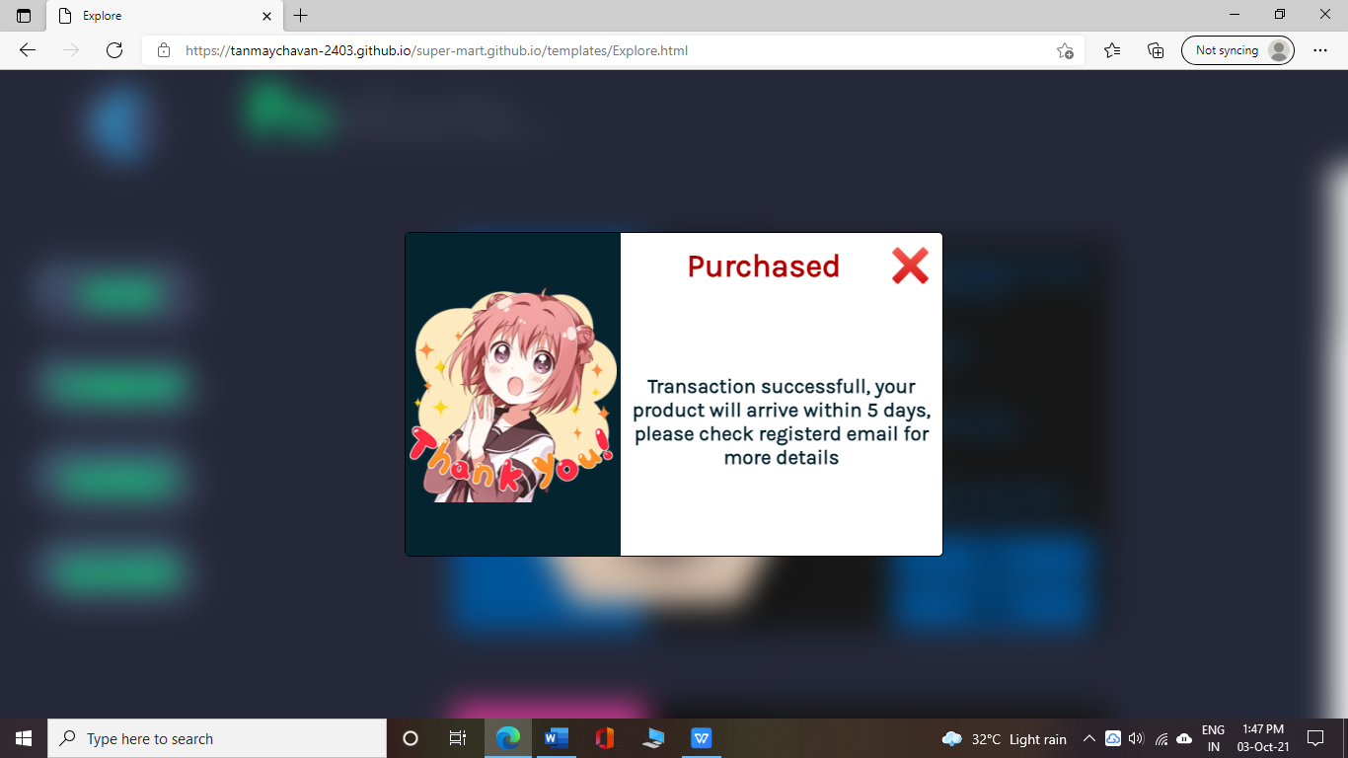

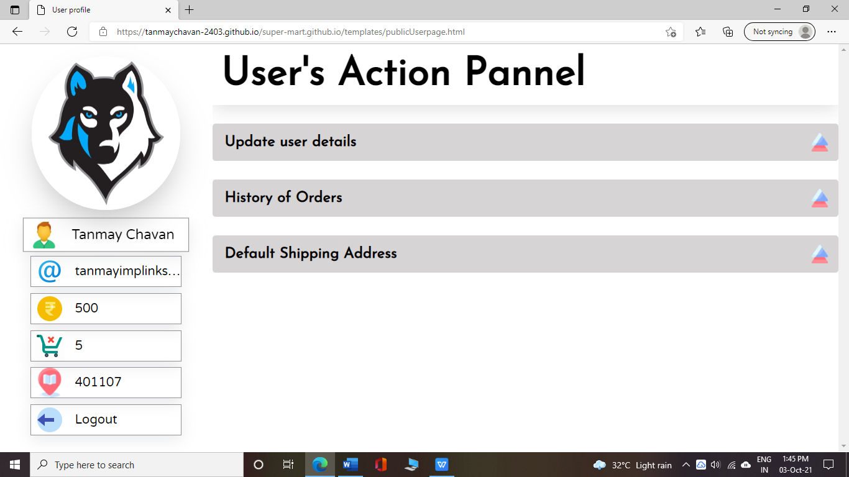

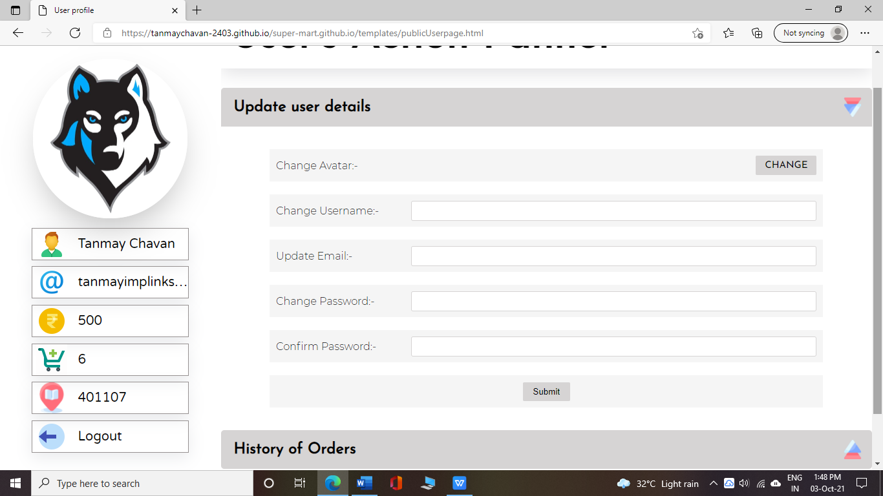

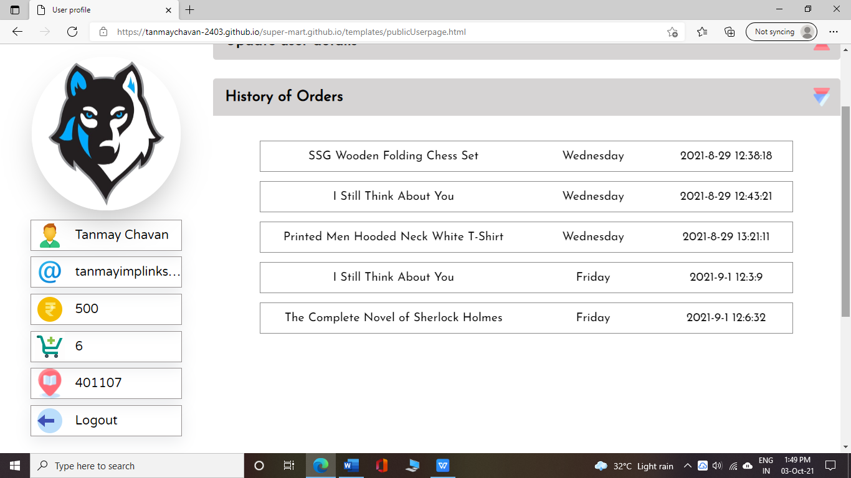

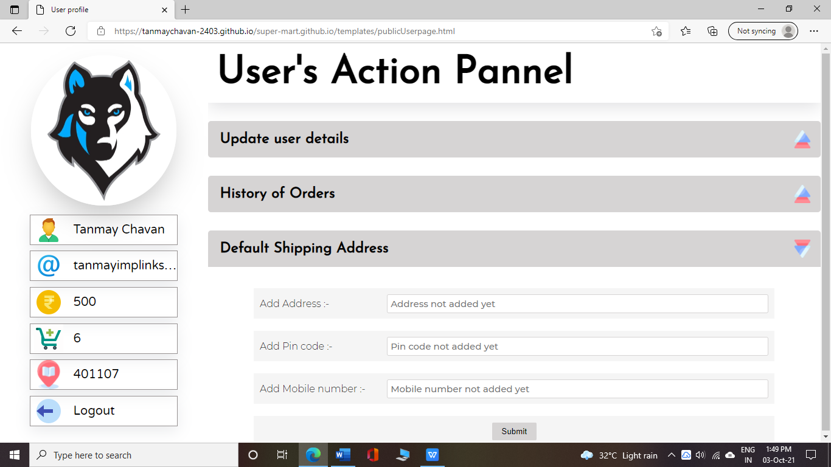

**Login.js**

**function login(username, password, callbackResp){**

**if (username === "" || password === ""){**

**callbackResp(["Failed", "Please don't leave fields blank"]);**

**return;**

**}**

**else{**

**console.log('Reading in login function');**

**firebase.database().ref(`Users/${username}`).on('value', (dataSet) => {**

**console.log('Went for firebase');**

**if (dataSet.exists()){**

**const credential = dataSet.val();**

**if (credential['password'] === password){**

**callbackResp(['Success']);**

**} else {**

**callbackResp(['Failed', 'Password does not match']);**

**}**

**} else {**

**callbackResp(['Failed', 'Username not found, please Regester first']);**

**}**

**});**

**}**

**}**

**Registration.js**

**function updateDatabase(value, type, path){**

**firebase.database().ref(`${path}/${type}`).get().then(dataSet => {**

**if (Array.isArray(dataSet.val())){**

**let credentials = dataSet.val();**

**credentials.push(value);**

**firebase.database().ref(`${path}/${type}`).set(credentials);**

**}else{**

**let credentials = [dataSet.val()];**

**credentials.push(value);**

**firebase.database().ref(`${path}/${type}`).set(credentials);**

**}**

**});**

**}**

**async function register(username, password, email){**

**console.log(`CRL => Register and values are ${username} & ${password} & ${email}`);**

**if (username == "" || password == "" || email == ""){**

**return "please don't leave fields empty"**

**}**

**var avatarPaths = ['Avatars/Avatar 1.png', 'Avatars/Avatar 2.png', 'Avatars/Avatar 3.png',**

**'Avatars/Avatar 4.png', 'Avatars/Avatar 5.png','Avatars/Avatar 6.png', 'Avatars/Avatar 7.png',**

**'Avatars/Avatar 8.png', 'Avatars/Avatar 9.png', 'Avatars/Avatar 10.png', 'Avatars/Avatar 11.png',**

**'Avatars/Avatar 12.png', 'Avatars/Avatar 13.png', 'Avatars/Avatar 14.png']**

**let random = Math.floor(Math.random() * avatarPaths.length);**

**console.log('HEHE' + username);**

**let resp = await valid(username, password, email, 'register');**

**if (resp[0] === 'Success'){**

**console.log('Successfully Regestired');**

**firebase.database().ref(`Users/${username}`).set({**

**username: username,**

**email: email,**

**password: password,**

**balance: 500,**

**address: "",**

**status: "",**

**pinCode: "",**

**MobNumber: "",**

**avatar: avatarPaths[random],**

**totalPurchase: 0,**

**orders: ["None"]**

**})**

**// Logic to add username , email and password in their respective directory**

**updateDatabase(username, 'usernames', 'U');**

**updateDatabase(password, 'passwords', 'P');**

**updateDatabase(email, 'emails', 'E');**

**}**

**else{**

**return `${resp[1]} already taken`;**

**}**

**}**

**User detials.js**

**function storeDataInSession(data, callbackResp){**

**sessionStorage.setItem('Avatar', data['avatar']);**

**sessionStorage.setItem('Email', data['email']);**

**sessionStorage.setItem('Status', data['status']);**

**sessionStorage.setItem('PinCode', data['pinCode']);**

**sessionStorage.setItem('Balance', data['balance']);**

**sessionStorage.setItem('Address', data['address']);**

**sessionStorage.setItem('MobileNumber', data['MobNumber']);**

**sessionStorage.setItem('TotalPurchase', data['totalPurchase']);**

**sessionStorage.setItem('Password', data['password']);**

**callbackResp();**

**}**

**function getUserDetails(callbackResp){**

**var DBreference = firebase.database().ref(`Users/${sessionStorage.getItem('User')}`);**

**DBreference.get()**

**.then(resp => {**

**if (resp.exists()){**

**storeDataInSession(resp.val(), callbackResp);**

**} else {**

**console.log('No records found');**

**}**

**})**

**.catch(err => {**

**console.log('Opps! Error Encountered', err);**

**})**

**}**

**function fetchImageForAvatar(callbackResp){**

**var imgPath = sessionStorage.getItem('Avatar');**

**var firestore = firebase.storage();**

**firestore.ref(imgPath).getDownloadURL()**

**.then(resp => {**

**callbackResp(resp);**

**sessionStorage.setItem('AvatarURL', resp)**

**})**

**.catch(err => {**

**// callbackResp('Opps! Sorry to inform you pal, but something went wrong while**

**// fetching data :( ');**

**callbackResp('404');**

**callbackResp(err);**

**})**

**}**

**function updateAddress(callbackResp){**

**let address = document.getElementById('address').value;**

**let pinCode = document.getElementById('pin-code').value;**

**let mobileNumber = document.getElementById('mobileNumber').value;**

**var username = sessionStorage.getItem('User');**

**var updates = {}**

**updates[`Users/${username}/address`] = address;**

**updates[`Users/${username}/pinCode`] = pinCode;**

**updates[`Users/${username}/MobNumber`] = mobileNumber;**

**sessionStorage.setItem('PinCode', pinCode);**

**sessionStorage.setItem('address', address);**

**sessionStorage.setItem('MobNumber', mobileNumber);**

**var resp = firebase.database().ref().update(updates, callbackResp('Update Successfull'));**

**}**

**function allEmpty(cred1, cred2, cred3, cred4){**

**if (cred1 === "" && cred2 === "" && cred3 === "" && cred4 === ""){**

**return true**

**} else {**

**return false**

**}**

**}**

**function updateUserDetails(){**

**var username = document.getElementById('User').value;**

**var email = document.getElementById('Email').value;**

**var password = document.getElementById('password').value;**

**var ConfmPassword = document.getElementById('confirmPassword').value;**

**if (allEmpty(username, email, password, ConfmPassword)){**

**displayStatus('500', 'Nothing to update');**

**}**

**if(username !== ""){**

**if (username === sessionStorage.getItem('User')){**

**displayStatus('500', 'You are choosing same username');**

**return;**

**} else if (username.includes('.') || username.includes('/')){**

**displayStatus('500', "Please don't use '.' or '/' in your username");**

**return;**

**}**

**let usernameID;**

**var flag = true;**

**var DBreference = firebase.database().ref(`U/usernames`);**

**DBreference.get()**

**.then(resp => {**

**if (resp.exists()){**

**// For loop to check weather new username already taken by someone**

**// else and simultaneously**

**// Take the id of the username which we have to change in**

**// case the username is not taken**

**// by anyone else which is stored in usernameID**

**for(let i = 0; i < resp.val().length; i++){**

**if (sessionStorage.getItem('User') === resp.val()[i]){**

**usernameID = i;**

**}**

**if (username === resp.val()[i]){**

**displayStatus('500', 'Username already exists!');**

**flag = false;**

**}**

**}**

**// If we reach till this if condition means the new username is not**

**// taken by anyone**

**// so now we can proceed further with updation of user data**

**if (flag && usernameID !== undefined){**

**// Getting old data from database to assing it to new username**

**firebase.database().ref(`Users/${sessionStorage.getItem('User')}`).get()**

**.then(resp => {**

**if (resp.exists()){**

**var Newdata = resp.val();**

**// Before assigning the data to new username we change the username present in data**

**Newdata['username'] = username;**

**firebase.database().ref(`Users/${username}`).set(Newdata)**

**.then(resp => displayStatus('200', 'Successfully Updated User'))**

**.catch(err => displayStatus('500', 'Could not update username'));**

**} else {**

**console.log('No Data found on server :( ');**

**}**

**})**

**.catch(err => {**

**console.log('firebase Error', err);**

**})**

**// Deleting the old username with its values**

**firebase.database().ref(`Users/${sessionStorage.getItem('User')}`).remove();**

**// Deleting the record from usernames field**

**firebase.database().ref(`U/usernames/${usernameID}`).set(username);**

**// Updating the value of username in sessionStorage**

**sessionStorage.setItem('User', username);**

**}**

**} else {**

**displayStatus('500', 'Internal Error! Please try again later');**

**}**

**})**

**.catch(err => {**

**console.log('Opps! we have Encountered an error', err);**

**})**

**}**

**// Applying timeout because if we are having username and email both for**

**// update then we have to wait for atleast 2 seconds or else it will overlap**

**setTimeout(() => {**

**if(email !== ""){**

**const re = /^\w+@[a-zA-Z_]+?\.[a-zA-Z]{2,3}$/;**

**if (re.test(email) && (email.includes('gmail.com') || email.includes('yahoo.com'))){**

**let emailID;**

**var flag = true;**

**firebase.database().ref('E/emails').get()**

**.then(resp => {**

**for(let i = 0; i < resp.val().length; i++){**

**if (sessionStorage.getItem('Email') === resp.val()[i]){**

**emailID = i;**

**console.log('We got our email ID', emailID);**

**}**

**if (email === resp.val()[i]){**

**displayStatus('500', 'This email is already registered');**

**flag = false;**

**}**

**}**

**if (flag && emailID !== undefined){**

**// Updating email of user**

**firebase.database().ref(`Users/${sessionStorage.getItem('User')}/email`).set(email)**

**.then(response => {**

**displayStatus('200','Successfully Updated Email');**

**// Updating the email in session storage**

**sessionStorage.setItem('Email', email);**

**firebase.database().ref(`E/emails/${emailID}`).set(email);**

**})**

**.catch(err => {**

**displayStatus('500','Could not update email');**

**console.log(err);**

**});**

**}**

**})**

**.catch(err => {**

**displayStatus('500', 'Internal Error');**

**console.log(err);**

**});**

**} else {**

**displayStatus('500', 'Please enter valid Email');**

**}**

**}**

**// Code to update password if entered**

**if (password !== ""){**

**if (ConfmPassword === ""){**

**displayStatus('500', 'Please also enter the confirm password');**

**return;**

**} else if (ConfmPassword !== password){**

**displayStatus('500', 'Password does not match with Confirm password');**

**return;**

**}**

**let passwordID;**

**var flag = true;**

**firebase.database().ref(`P/passwords`).get()**

**.then(resp => {**

**for(var i = 0; i < resp.val().length; i++){**

**if (sessionStorage.getItem('Password') === resp.val()[i]){**

**passwordID = i;**

**} else if(email === resp.val()[i]){**

**console.log('Reaching here');**

**displayStatus('500', 'Password is already in use');**

**flag = false;**

**}**

**if (flag && passwordID !== undefined){**

**// Updating password of the user**

**firebase.database().ref(`Users/${sessionStorage.getItem('User')}/password`).set(password)**

**.then(resp => {**

**// Updating passwords in session and passwords list in firebase**

**sessionStorage.setItem('Password', password);**

**firebase.database().ref(`P/passwords/${passwordID}`).set(password);**

**console.log('Password is updated ig');**

**displayStatus('200','Password updated successfully');**

**})**

**.catch(err => {**

**console.log('Opps! we have got an error', err);**

**})**

**}**

**}**

**})**

**.catch(err => {**

**console.log(err);**

**})**

**}**

**}, 2000)**

**}**

**function getAllAvatars(callbackResp){**

**var avatarPaths = ['Avatars/Avatar 1.png', 'Avatars/Avatar 2.png', 'Avatars/Avatar 3.png',**

**'Avatars/Avatar 4.png', 'Avatars/Avatar 5.png','Avatars/Avatar 6.png', 'Avatars/Avatar 7.png',**

**'Avatars/Avatar 8.png', 'Avatars/Avatar 9.png', 'Avatars/Avatar 10.png', 'Avatars/Avatar 11.png',**

**'Avatars/Avatar 12.png', 'Avatars/Avatar 13.png', 'Avatars/Avatar 14.png', 'Avatars/Avatar 15.gif'];**

**var data = {};**

**avatarPaths.forEach(path => {**

**firebase.storage().ref(path).getDownloadURL()**

**.then(url => {**

**firebase.storage().ref(path).getMetadata()**

**.then(metadata => {**

**data[path] = [metadata['name'], url];**

**if (path === 'Avatars/Avatar 14.png'){**

**setTimeout(()=> {**

**callbackResp(data);**

**sessionStorage.setItem('allAvatars', data);**

**}, 2000)**

**}**

**})**

**})**

**.catch(err => {**

**callbackResp(err);**

**})**

**})**

**}**

**// Function to update avatar of user**

**function updateAvatar(name, link){**

**if (name === undefined || link === undefined){**

**displayStatus('500', 'Please select avatar first');**

**return;**

**}**

**console.log('Updating details');**

**console.log(name, link);**

**// Updating avatar details in database**

**firebase.database().ref(`Users/${sessionStorage.getItem('User')}/avatar`).set(name)**

**.then(resp => displayStatus('200', 'Successfully Updated'))**

**.catch(err => displayStatus('500', 'Internal Error'))**

**// updating avatar name & url in session storage**

**sessionStorage.setItem('Avatar', name);**

**sessionStorage.setItem('AvatarURL', link);**

**// Rerloading page after updating avatar to display updates**

**setTimeout(() => {**

**location.reload();**

**}, 2000);**

**}**

**function getCurrentWeekDay(returnDate){**

**switch(new Date().getDay()){**

**case 0:**

**returnDate("Sunday");**

**break**

**case 1:**

**returnDate("Monday");**

**break**

**case 2:**

**returnDate("Tuesday");**

**break**

**case 3:**

**returnDate("Wednesday");**

**break**

**case 4:**

**returnDate("Thursday");**

**break**

**case 5:**

**returnDate("Friday");**

**break**

**case 6:**

**returnDate("Saturday");**

**}**

**}**

**// Function to update orders list of user when he orders something**

**function bookOrBuyProduct(imgPath, prodName, callbackFunc){**

**let currUser = sessionStorage.getItem('User');**

**let d = new Date();**

**let currDay = `${d.getFullYear()}-${d.getMonth()}-${d.getDate()}`;**

**let currTime = `${d.getHours()}:${d.getMinutes()}:${d.getSeconds()}`;**

**let totalOrders = parseInt(sessionStorage.getItem('TotalPurchase'));**

**getCurrentWeekDay(weekDay => {**

**let orderData = {**

**'orderName': prodName,**

**'orderImg' : imgPath,**

**'orderWeekDay' : weekDay,**

**'orderCurrTime' : `${currDay} ${currTime}`**

**}**

**var currUpdate = {};**

**// add order details**

**currUpdate[`Users/${sessionStorage.getItem('User')}/orders/${totalOrders}`] = orderData;**

**firebase.database().ref().update(currUpdate);**

**// Updating total order count in session storage**

**sessionStorage.setItem('TotalPurchase', totalOrders + 1)**

**// Updating total order count in database**

**firebase.database().ref(`Users/${sessionStorage.getItem('User')}/totalPurchase`).set(totalOrders + 1)**

**.then(resp => callbackFunc('200'))**

**.catch(err => callbackFunc('500'))**

**// Calling success callback function**

**})**

**}**

**// Function to fetch order details**

**function getOrderHistory(user, callbackFunc){**

**firebase.database().ref(`Users/${user}/orders`).get()**

**.then(resp => {**

**sessionStorage.setItem('orders', JSON.stringify(resp.val()))**

**callbackFunc('200');**

**})**

**.catch(err => {**

**console.log(err)**

**callbackFunc('500');**

**})**

**}**

**FireStore.js**

**let chooseFileBtn = document.getElementById('chooseFileButton');**

**function upload(){**

**var file = document.getElementById('inputFileButton').files[0];**

**// Updating path for filepath**

**path += file.name;**

**filePath.value = path;**

**// Creating reference to storage**

**console.log(path, 'from Firestore');**

**const storageRef = firebase.storage().ref(path);**

**// Upload File**

**const task = storageRef.put(file);**

**// Upload progress**

**task.on("state_changed",**

**function progress(snapshot){**

**console.log('Progressing....');**

**},**

**function error(err){**

**console.log('Opps! We have got as error' + err);**

**displayStatus('500', 'Image not Uploaded');**

**},**

**function complete(){**

**console.log('Its completed IG');**

**displayStatus('200', 'Image uploaded Successfully');**

**}**

**)**

**}**

**function uploadFileData(){**

**var firestore = firebase.firestore();**

**const fileName = document.getElementById('file-name').value;**

**const filePath = document.getElementById('file-path').value;**

**const Price = document.getElementById('price').value;**

**const totalImages = document.getElementById('total-images').value;**

**const totalProducts = document.getElementById('total-products').value;**

**const collection = filePath.split('/')[0];**

**console.log(collection, 'From file upload section');**

**var docRef = firestore.collection(collection);**

**if (filePath === "") {**

**alert('Please complte previous procedures first');**

**return;**

**} else {**

**docRef.add({**

**Name: fileName,**

**Path: filePath,**

**Price: Price,**

**totalImages: totalImages,**

**totalProducts: totalProducts**

**})**

**.then( resp => {**

**console.log('Databse updated successfully :) ', resp);**

**displayStatus('200', 'Data uploaded successfully');**

**})**

**.catch(err => {**

**console.log('Opps!, We have got an error :( ', err);**

**displayStatus('500', 'Failed to upload data');**

**})**

**// docRef.get()**

**// .then(resp => {**

**// resp.forEach(doc => {**

**// console.log(doc.data());**

**// })**

**// })**

**// .catch(err => {**

**// console.log(err);**

**// })**

**}**

**// docRef.set({**

**// YoMyFirstLog: 'Hey Hey Hey!',**

**// }).then(resp => {**

**// console.log('Yayy, We have update the database successfully :) ');**

**// }).catch(err => {**

**// console.log('Opps! we have got an error :( ', err);**

**// })**

**}**

**function fetchDataFromDatabase(collection, callbackResp){**

**var firestore = firebase.firestore();**

**var docRef = firestore.collection(collection);**

**response = []**

**docRef.get()**

**.then(resp => {**

**resp.forEach(doc => {**

**response.push(doc.data());**

**})**

**callbackResp(response);**

**})**

**.catch(err => {**

**console.log('Opps! We Encountered an error :( ', err);**

**})**

**}**

**// Function to apply images on received cards**

**function fetchImageUrls(cards, collection, callbackResp){**

**var firestore = firebase.storage();**

**result = {};**

**cards.forEach(card => {**

**firestore.ref(card.getAttribute('data-imgPath')).getDownloadURL()**

**.then(resp => {**

**card.children[0].src = resp;**

**result[card.getAttribute('data-imgPath')] = resp;**

**})**

**.catch(err => {**

**console.log(err);**

**})**

**})**

**callbackResp();**

**setTimeout(() => {**

**if (!(Object.keys(result).length === 0 && result.constructor === Object)){**

**sessionStorage.setItem(collection, JSON.stringify(result));**

**} else {**

**console.log('Result was empty so we didnt updated sesstion storage');**

**}**

**}, 5000)**

**}**

**Valid.js**

**# This 2 functions help to validated the users while sign-up/ registration**

**function Exists(target, type, root){**

**return new Promise((resolve, reject) => {**

**let records;**

**firebase.database().ref(`${root}/${type}`).once("value", function(dataSet){**

**if (dataSet.exists()){**

**records = dataSet.val();**

**for (let i = 0; i < records.length; i++){**

**if (target === records[i]){**

**reject(type);**

**return;**

**}**

**}**

**resolve('Success');**

**}**

**else{**

**resolve('Success');**

**}**

**});**

**});**

**}**

**async function valid(username, password, email, type){**

**if (type === 'register'){**

**try{**

**await Exists(username, 'usernames', 'U');**

**await Exists(email, 'emails', 'E');**

**await Exists(password, 'passwords', 'P');**

**} catch(err) {**

**return ['Failed', err];**

**}**

**return ['Success'];**

**}**

**}**

**Account.html**

**<!DOCTYPE html>**

**<html lang="en">**

**<head>**

**<meta charset="UTF-8">**

**<meta http-equiv="X-UA-Compatible" content="IE=edge">**

**<meta name="viewport" content="width=device-width, initial-scale=1.0">**

**<link rel="stylesheet" href="../static/css/Account.css">**

**<link rel="preconnect" href="https://fonts.googleapis.com">**

**<link rel="preconnect" href="https://fonts.gstatic.com" crossorigin>**

**<link href="https://fonts.googleapis.com/css2?family=ABeeZee&family=Goudy+Bookletter+1911&family=Kavoon&family=Montserrat:wght@500&family=Nunito:wght@700&display=swap" rel="stylesheet">**

**<link href="https://fonts.googleapis.com/css2?family=Raleway:wght@100;200&display=swap" rel="stylesheet">**

**<link href="https://fonts.googleapis.com/css2?family=Poppins:wght@100;300&display=swap" rel="stylesheet">**

**<script src="../scripts/Registration.js"></script>**

**<script src="../scripts/login.js"></script>**

**<script src="../scripts/valid.js"></script>**

**<script src="../scripts/userDetails.js"></script>**

**<script src="https://www.gstatic.com/firebasejs/8.9.1/firebase.js"></script>**

**<script src="../scripts/firestoreConfig.js"></script>**

**<title>Document</title>**

**</head>**

**<body>**

**<div class="main-container">**

**<img src="../static/Images/AccountBG.png" alt="">**

**<div class="mask"></div>**

**<div class="login-registration">**

**<div id="page3" class="pg">**

**<div class="registration-avatar">**

**<img src="../static/Images/account/avatar.png" alt="">**

**</div>**

**<div class="reg-input-field" id='username'>**

**<input type="text" placeholder="Username">**

**</div>**

**<div class="reg-input-field" id='email'>**

**<input type="text" placeholder="Email">**

**</div>**

**<div class="reg-input-field" id="password">**

**<input type="password" placeholder="Password">**

**</div>**

**<div class="reg-buttons">**

**<div class="prev-page" onclick="prevPage()">**

**<img src="../static/Images/accountArrow.png" alt="">**

**</div>**

**<div class="reg-submit-button" onclick="regSubmit()">**

**<h2>SUBMIT</h2>**

**</div>**

**</div>**

**</div>**

**<div id="page2" class="pg">**

**<div class="regestrantion-image">**

**<img src="../static/Images/account/registration.png" alt="Registration Image">**

**</div>**

**<div class="login-inputs">**

**<div class="page2Avatar">**

**<img src="../static/Images/account/avatar.png" alt="">**

**</div>**

**<div class="username login-input-field">**

**<input type="text" placeholder="Username / Email">**

**</div>**

**<div class="password login-input-field">**

**<input type="password" placeholder="Password">**

**</div>**

**<div class="login-subimt" >**

**<div class="submit-button" onclick="loginSubmit()">**

**<h2>SUBMIT</h2>**

**</div>**

**<div class="next-page" onclick="nextPage()">**

**<img src="../static/Images/accountArrow.png" alt="">**

**</div>**

**</div>**

**</div>**

**</div>**

**<div id="page1" class="pg">**

**<div class="p1Image">**

**<img src="../static/Images/account/Login.png" alt="Login Image">**

**</div>**

**<div class="login-registration-button">**

**<div class="LRB-message">**

**Where you wanna go ?**

**</div>**

**<div class="LRB-btn">**

**<h2>LOGIN</h2>**

**</div>**

**<div class="LRB-btn" id="LRB-reg" onclick="navigateToRegPage()">**

**<h2>REGISTRATION</h2>**

**</div>**

**</div>**

**</div>**

**</div>**

**</div>**

**<div id="status-container">**

**<div id="status-frame">**

**<div id="status-gif">**

**<img src="" alt="" id="gif-container">**

**</div>**

**<div id="status-message">**

**<h1> Registration Successfull </h1>**

**</div>**

**</div>**

**</div>**

**<script>**

**buttons = document.querySelectorAll('.LRB-btn');**

**buttons.forEach(btn => {**

**btn.addEventListener('click', function(e){**

**let targetVal = btn.children[0].innerText;**

**if (targetVal == 'LOGIN'){**

**// To turn page**

**var container = document.querySelector('#page1');**

**container.style.transform = 'perspective(1300px) rotateY(-179deg)';**

**// To make login image visible again**

**var image = document.querySelector('.p1Image').getElementsByTagName('img');**

**image[0].style.opacity = '1';**

**image[0].style.transform = 'translateY(-5%)';**

**// To increase size of login-registration container**

**var container2 = document.querySelector('.login-registration');**

**container2.style.width = '60%';**

**let pages = document.querySelectorAll('.pg');**

**pages.forEach(page => {**

**if (page['id'] == 'page1'){**

**page.style.transform = 'perspective(1300px) rotateY(-179deg) translateX(-51%)';**

**}**

**else{**

**page.style.transform = 'translate(50%)';**

**}**

**});**

**}**

**});**

**});**

**// Function to get ripples on submit button**

**let btn = document.querySelector('.submit-button');**

**btn.addEventListener('click', function(e){**

**var x = e.layerX + 10;**

**var y = e.layerY + 5;**

**let ripple = document.createElement('span');**

**ripple.style.left = x + 'px';**

**ripple.style.top = y + 'px';**

**this.appendChild(ripple);**

**setTimeout(() => {**

**ripple.remove()**

**}, 600);**

**});**

**// Function to go on registration page from login page**

**function nextPage(){**

**// ACTIONS REQUIRED TO FLIP PAGE 2**

**let button = document.getElementById('page2');**

**button.style.transform = 'perspective(1300px) rotateY(-179deg) translateX(49%)';**

**button.style.zIndex = '2'**

**let container = document.querySelector('.login-inputs');**

**container.style.transformStyle = 'preserve-3d';**

**// To make login image invisible again**

**var image = document.querySelector('.p1Image').getElementsByTagName('img');**

**image[0].style.opacity = '0';**

**image[0].style.transform = 'translateY(-15%)';**

**image[0].style.transitionDelay = '0s';**

**// To activate the pointer events on last page ( page 3)**

**let page3 = document.getElementById('page3');**

**page3.style.pointerEvents = 'auto';**

**};**

**// Function to go back to login page from registration page**

**function prevPage(){**

**// ACTIONS REQUIRED TO FLIP PAGE 2 in reverse direction**

**let button = document.getElementById('page2');**

**button.style.transform = 'rotateY(0deg) translateX(51%)';**

**button.style.zIndex = '0'**

**let container = document.querySelector('.login-inputs');**

**container.style.transformStyle = 'preserve-3d';**

**// To make login image visible again**

**var image = document.querySelector('.p1Image').getElementsByTagName('img');**

**image[0].style.opacity = '1';**

**image[0].style.transform = 'translateY(-5%)';**

**image[0].style.transitionDelay = '.s';**

**// To deactivate the pointer events on last page ( page 3)**

**let page3 = document.getElementById('page3');**

**page3.style.pointerEvents = 'none';**

**}**

**//To submit login details**

**async function loginSubmit(){**

**console.log('Reaching here');**

**// TAKING INPUT DATA FROM LOGIN INPUT FIELDS**

**var username = document.querySelector('.username').children[0].value;**

**var password = document.querySelector('.password').children[0].value;**

**login(username, password, function (resp){**

**console.log(`In Account.html ${resp}`);**

**// Taking all the containers for showing status window**

**document.getElementById('status-container').style.opacity = '1';**

**document.getElementById('status-container').style.pointerEvents = 'visible';**

**let imageContainer = document.getElementById('status-gif');**

**let messageContainer = document.getElementById('status-message');**

**let frameContainer = document.getElementById('status-frame');**

**let gifContainer = document.getElementById('gif-container');**

**// IF we get a failed response then we have to show cross mark gif and**

**// what went wrong or else, a check mark with login successfull message**

**if (resp[0] === 'Failed'){**

**gifContainer.src = '../static/Images/account/regWrong.gif';**

**messageContainer.children[0].innerHTML = resp[1];**

**messageContainer.style.color = 'rgb(248, 58, 58)';**

**} else {**

**gifContainer.src = '../static/Images/account/regCheck.gif';**

**messageContainer.children[0].innerHTML = `Login Successfull`;**

**messageContainer.style.color = "rgb(3, 146, 3)";**

**setTimeout(() => {**

**sessionStorage.setItem("User", username);**

**getUserDetails(() => {**

**if (resp){**

**console.log('Master user', username);**

**location.href = '../index.html';**

**} else {**

**console.log('Public user', username);**

**location.href = '../index.html';**

**}**

**})**

**}, 3000);**

**}**

**// Logic to disable status window automatically after 3 seconds**

**setTimeout(() => {**

**console.log('Reached here second');**

**document.getElementById('status-container').style.opacity = '0';**

**document.getElementById('status-container').style.pointerEvents = 'none';**

**}, 3000);**

**});**

**}**

**function navigateToRegPage(){**

**var page1 = document.getElementById('page1');**

**var page3 = document.getElementById('page3');**

**// To turn page**

**page1.style.transform = 'perspective(1300px) rotateY(-179deg)';**

**// To increase size of login-registration container**

**var container2 = document.querySelector('.login-registration');**

**container2.style.width = '60%';**

**let pages = document.querySelectorAll('.pg');**

**pages.forEach(page => {**

**if (page['id'] == 'page1'){**

**page.style.transform = 'perspective(1300px) rotateY(-179deg) translateX(-51%)';**

**}**

**else{**

**page.style.transform = 'translate(50%)';**

**}**

**});**

**setTimeout(function(){**

**// ACTIONS REQUIRED TO FLIP PAGE 2**

**let button = document.getElementById('page2');**

**button.style.transform = 'perspective(1300px) rotateY(-179deg) translateX(49%)';**

**button.style.zIndex = '2'**

**let container = document.querySelector('.login-inputs');**

**container.style.transformStyle = 'preserve-3d';**

**// To activate the pointer events on last page ( page 3)**

**let page3 = document.getElementById('page3');**

**page3.style.pointerEvents = 'auto';**

**}, 400)**

**}**

**function regSubmit(){**

**// TAKING INPUT DATA FROM LOGIN INPUT FIELDS**

**let username = document.getElementById('username').children[0].value;**

**let password = document.getElementById('password').children[0].value;**

**let email = document.getElementById('email').children[0].value;**

**// console.log('CRL => Account.html => ', username, password, email);**

**let resp = register(username, password, email);**

**resp.then(message =>{**

**// Taking all the containers for showing status window**

**document.getElementById('status-container').style.opacity = '1';**

**document.getElementById('status-container').style.pointerEvents = 'visible';**

**let imageContainer = document.getElementById('status-gif');**

**let messageContainer = document.getElementById('status-message');**

**let frameContainer = document.getElementById('status-frame');**

**let gifContainer = document.getElementById('gif-container');**

**// IF we get a failed response then we have to show cross mark gif and**

**// what went wrong or else, a check mark with login successfull message**

**if (!(message == undefined)){ // Means we failed**

**gifContainer.src = '../static/Images/account/regWrong.gif';**

**messageContainer.children[0].innerHTML = message;**

**messageContainer.style.color = 'rgb(248, 58, 58)';**

**}else{**

**gifContainer.src = '../static/Images/account/regCheck.gif';**

**messageContainer.children[0].innerHTML = `Registration Successfull`;**

**messageContainer.style.color = "rgb(3, 146, 3)";**

**setTimeout(() => {**

**sessionStorage.setItem("User", username);**

**getUserDetails(() => {**

**console.log('Public user', username);**

**location.href = '../index.html';**

**})**

**}, 3000);**

**}**

**//Logic to disable status window automatically after 3 seconds of error window**

**setTimeout(() => {**

**console.log('Reached here second');**

**// document.getElementById('status-container').style.display = 'none';**

**document.getElementById('status-container').style.opacity = '0';**

**document.getElementById('status-container').style.pointerEvents = 'none';**

**}, 3000);**

**});**

**}**

**</script>**

**</body>**

**</html>**

**Explore.html**

**<!DOCTYPE html>**

**<html lang="en">**

**<head>**

**<meta charset="UTF-8">**

**<meta http-equiv="X-UA-Compatible" content="IE=edge">**

**<meta name="viewport" content="width=device-width, initial-scale=1.0">**

**<link rel="preconnect" href="https://fonts.googleapis.com">**

**<link rel="preconnect" href="https://fonts.gstatic.com" crossorigin>**

**<script src="https://www.gstatic.com/firebasejs/8.9.1/firebase.js"></script>**

**<script src="https://www.gstatic.com/firebasejs/8.9.1/firebase-firestore.js"></script>**

**<link href="https://fonts.googleapis.com/css2?family=Josefin+Sans:wght@100;200;400&family=Pacifico&family=Poppins:wght@100;500&family=Varela+Round&display=swap" rel="stylesheet">**

**<link href="https://fonts.googleapis.com/css2?family=Montserrat+Alternates&display=swap" rel="stylesheet">**

**<link href="https://fonts.googleapis.com/css2?family=Lilita+One&display=swap" rel="stylesheet">**

**<link href="https://fonts.googleapis.com/css2?family=Karla:wght@200;400&family=Rubik:wght@300;500&family=Source+Sans+Pro:wght@600&display=swap" rel="stylesheet">**

**<link rel="stylesheet" href="../static/css/Explore.css">`**

**<script src="../scripts/userDetails.js"></script>**

**<title> Explore </title>**

**</head>**

**<body>**

**<div id="navigation-pannel">**

**<div id="back-button" onclick="navigate()">**

**<img src="../static/Images/explore/backArrow.png" alt="">**

**</div>**

**<div id="navigation-menu">**

**<a href="../index.html">**

**<div id="home-button" class="nvg-buttons">**

**<h2>HOME</h2>**

**</div>**

**</a>**

**<a href="Explore.html">**

**<div id="category-button" class="nvg-buttons">**

**<h2>CATEGORY</h2>**

**</div>**

**</a>**

**<a href="">**

**<div id="contact-button" class="nvg-buttons">**

**<h2>CONTACT</h2>**

**</div>**

**</a>**

**<a href="javascript:void(0)">**

**<div id="account-button" class="nvg-buttons">**

**<h2>ACCOUNT</h2>**

**</div>**

**</a>**

**</div>**

**</div>**

**<div id="right-pannel">**

**<div id="category-heading">**

**<h1 data-text='Categories...'> Categories...</h1>**

**</div>**

**<div id="category-pannel">**

**<div id="categories">**

**<div class="wrapper">**

**<div class="category-cards" onclick="changeLayer(0, 'Stationery')">**

**<img src="../static/Images/explore/Stationery.jpg" alt="">**

**<div class="cards-heading">**

**<h2>STATIONERY</h2>**

**</div>**

**</div>**

**</div>**

**<div class="wrapper">**

**<div class="category-cards" onclick="changeLayer(1, 'Electronics')">**

**<img src="../static/Images/explore/Electornics.jpg" alt="">**

**<div class="cards-heading">**

**<h2>ELECTRONICS</h2>**

**</div>**

**</div>**

**</div>**

**<div class="wrapper">**

**<div class="category-cards" onclick="changeLayer(2, 'Clothes')">**

**<img src="../static/Images/explore/clothes.jpg" alt="">**

**<div class="cards-heading">**

**<h2>CLOTHES</h2>**

**</div>**

**</div>**

**</div>**

**<div class="wrapper">**

**<div class="category-cards" onclick="changeLayer(3, 'Sports')">**

**<img src="../static/Images/explore/sports.png" alt="">**

**<div class="cards-heading">**

**<h2>SPORTS</h2>**

**</div>**

**</div>**

**</div>**

**<div class="wrapper">**

**<div class="category-cards" onclick="changeLayer(4, 'Toys')">**

**<img src="../static/Images/explore/Toys.jpg" alt="">**

**<div class="cards-heading">**

**<h2>TOYS</h2>**

**</div>**

**</div>**

**</div>**

**<div class="wrapper">**

**<div class="category-cards" onclick="changeLayer(5, 'Books')">**

**<img src="../static/Images/explore/Books.jpg" alt="">**

**<div class="cards-heading">**

**<h2>BOOKS</h2>**

**</div>**

**</div>**

**</div>**

**</div>**

**</div>**

**<div id="loader">**

**<h1 id="glitch">**

**Loading Data...**

**<span>Loading Data...</span>**

**<span>Loading Data...</span>**

**</h1>**

**</div>**

**<!-- Will be updated dynamically in items-pannel-->**

**<div id="items-pannel" onload="removeLoader()"></div>**

**</div>**

**<div id="purchaseBase-container">**

**<div id="purchase-container">**

**<div id="purchaseImage-container">**

**<img src="" alt="Error to update Pincode">**

**</div>**

**<div id="purchaseMessage-container">**

**<div id="purchaseMessageTitle-container">**

**<h2>**

**<!-- Will be updated dynamically -->**

**</h2>**

**<img src="../static/Images/purchase/close.png" onclick="closePurchaseContainer()">**

**</div>**

**<h4>**

**<!-- Will be update dynamically -->**

**</h4>**

**</div>**

**</div>**

**<div id="purchaseInfoBox">**

**<div id="InfoImgContainer">**

**<img src="../static/Images/purchase/Info.png" alt="Info container image">**

**</div>**

**<div id="InfoMessage-container">**

**<div id="InfoMessage">**

**<h4>**

**<!-- If you are planning to book the product, then please read this message carefully. Inorder to book any product**

**you have to pay 20% of the product price to reserve that item for you. It will be in our shop for one month from the**

**date of booking, so you can come in shop, show receipt, pay remaining amount and take your product.**

**In case if you fail to purchase your booked product, then from the 20% payment only 10% will be refunded considering**

**someone else might have purchased that product and he couldn't because you booked. Please take your decision and**

**choose below option appriopriately that, do you wish to proceed further or not. -->**

**</h4>**

**</div>**

**<div id="InfoActionButtons">**

**<button > Yes </button>**

**<button > No </button>**

**</div>**

**</div>**

**</div>**

**</div>**

**<script>**

**// GLobal declaration**

**let navigationContainer = document.getElementById('navigation-pannel');**

**let categoryPannel = document.getElementById('category-pannel');**

**let categoryCards = document.querySelectorAll('.category-cards');**

**let loader = document.getElementById('loader');**

**let itemsPanel = document.getElementById('items-pannel');**

**let categoryHeading = document.getElementById('category-heading');**

**let navigationMenu = document.getElementById('navigation-menu');**

**let navPath = ['index.html'];**

**console.log(navPath);**

**// Function to user intersetion observer on cards**

**let cards = document.querySelectorAll('.category-cards');**

**let options = {**

**root: null,**

**threshold: 0.7,**

**rootMargin: "50px"**

**}**

**let observer = new IntersectionObserver(function(entries, observer){**

**entries.forEach(entry => {**

**entry.target.style.opacity = entry.isIntersecting ? '1' : '0';**

**});**

**}, options)**

**cards.forEach(card => {**

**observer.observe(card);**

**});**

**// This function is executed when this page is loaded to update some elements and details**

**window.onload = () => {**

**if (sessionStorage.getItem('User') === null){**

**// navigationMenu.children[3].href = 'javascript:void(0)';**

**navigationMenu.children[3].style.cursor = 'not-allowed';**

**} else if (sessionStorage.getItem("User") === "Hackytech") {**

**console.log(navigationMenu.children[3].children[0]);**

**navigationMenu.children[3].href = 'MasterUserpage.html';**

**} else {**

**navigationMenu.children[3].href = 'publicUserpage.html';**

**}**

**}**

**// Changing layer to show the products in items pannel**

**function changeLayer(idx, collection){**

**navPath.push(idx);**

**//Changing heading for page**

**categoryHeading.children[0].innerHTML = "Products...";**

**categoryHeading.children[0].setAttribute('data-text', 'Products...');**

**// Scaling down the category card**

**var card = categoryCards[idx];**

**card.style.filter = 'none';**

**card.style.transform = 'scale(0, 1)';**

**// Fading out pannel on which categories are displayed**

**categoryPannel.style.transitionDelay = '.5s';**

**categoryPannel.style.opacity = '0';**

**setTimeout(() => {**

**fetchDataFromDatabase(collection, (resp) => {**

**// After fecthing data from database, we hide the category pannel**

**categoryPannel.style.display = 'none';**

**console.log('Products returned from database => ');**

**console.log(resp);**

**imgURLS = []**

**let colors = ['#0199d3', '#e11c25', '#d62750', '#fc9411', '#005499', '#18a6b0', '#66c8cb', '#8ccc03', '#c9368e', '#3d2a83']**

**while (itemsPanel.children.length > 0){**

**itemsPanel.removeChild(itemsPanel.children[0]);**

**}**

**resp.forEach(product => {**

**var color = colors[Math.floor(Math.random() * colors.length)]**

**itemsPanel.insertAdjacentHTML('afterbegin',**

**`**

**<div class="card">**

**<div class="hexagon-part">**

**<div class="productImg" data-imgPath="${product['Path']}">**

**<img src="" alt="">**

**</div>**

**</div>**

**<div class="right-part">**

**<div class="Rcontent">**

**<div class="details">**

**<div class="detl">**

**<div class="detlIcon">**

**<img src="../static/Images/explore/name.png" alt="">**

**</div>**

**<div class="detlInfo" style="color: ${color};">**

**<h3>${product['Name']}</h3>**

**</div>**

**</div>**

**<div class="detl">**

**<div class="detlIcon">**

**<img src="../static/Images/explore/rupee.png" alt="">**

**</div>**

**<div class="detlInfo" style="color: ${color};">**

**<h3>$${product['Price']}</h3>**

**</div>**

**</div>**

**<div class="detl">**

**<div class="detlIcon">**

**<img src="../static/Images/explore/stock.png" alt="">**

**</div>**

**<div class="detlInfo" style="color: ${color};">**

**<h3>${product['totalProducts']} In Stock</h3>**

**</div>**

**</div>**

**<div class="detl">**

**<div class="detlIcon">**

**<img src="../static/Images/explore/shop.png" alt="">**

**</div>**

**<div class="detlInfo" style="color: ${color};">**

**<h3>Royal Super Mart</h3>**

**</div>**

**</div>**

**</div>**

**<div class="purchaseOptions">**

**<button style="background-color: ${color};" onclick="purchase('${product['Path']}', '${product['Name']}', 'buy', '${product['Price']}', '${collection}' )"> Buy </button>**

**<br>**

**<button style="background-color: ${color};" onclick="purchase('${product['Path']}', '${product['Name']}', 'book', '${product['Price']}', '${collection}' )"> Book </button>**

**</div>**

**</div>**

**<div class="leftHexagonShadow"></div>**

**</div>**

**<div class="left-part" style="background: ${color};"></div>**

**</div>**

**`**

**)**

**imgURLS.push(product['Path']); // Storing image path so that later we can fetch it from database**

**});**

**// Getting all the productImg containers in will product image will be set**

**let cards = document.querySelectorAll('.productImg');**

**//Logic for setting images for cards which accepts collection, like for which**

**// collection we want data, electronics, stationery etc.**

**if (sessionStorage.getItem(collection)) { // So if we are already having stored images we will use them**

**let data = JSON.parse(sessionStorage.getItem(collection));**

**cards.forEach(card => {**

**card.children[0].src = data[card.getAttribute('data-imgPath')];**

**})**

**itemsPanel.style.display = 'flex';**

**} else {**

**console.log('Going for direct hit, data not found in cache for images');**

**fetchImageUrls(cards, collection, () => {**

**itemsPanel.style.display = 'flex';**

**});**

**}**

**})**

**// setTimeout(() => {**

**// loader.style.display = 'none';**

**// itemsPanel.style.display = 'flex';**

**// }, 2000);**

**}, 1700);**

**}**

**function removeLoader(){**

**console.log('Removing loader');**

**loader.style.display = 'none';**

**}**

**function purchase(path, name, type, price, collection){**

**// Enabling the status board**

**document.getElementById('purchaseBase-container').style.display = 'flex';**

**const productURL = JSON.parse(sessionStorage.getItem(collection))[path];**

**if (sessionStorage.getItem('User') === null){**

**document.getElementById('purchase-container').style.display = 'flex';**

**updateDetails("../static/Images/purchase/login message.gif", "Not LoggedIn", 'Please login/ register to book or buy any product');**

**}**

**else if ( type == 'book'){**

**// then show booking dialogue box instead purchase container**

**// and also set onclick event on buttons with the price**

**document.getElementById('InfoMessage').children[0].innerText = `If you are planning to book the product, then please read this message carefully. Inorder to book any product you have to pay 20% of the product price to reserve that item for you. It will be in our shop for one month from the date of booking, so you can come in shop, show receipt, pay remaining amount and take your product. In case if you fail to purchase your booked product, then from the 20% payment only 10% will be refunded considering omeone else might have purchased that product and he couldn't because you booked. Please take your decision and choose below option appriopriately that, do you wish to proceed further or not.`;**

**document.getElementById('purchaseInfoBox').style.display = 'flex';**

**document.getElementById('InfoActionButtons').children[0].setAttribute('onclick', `bookProduct('Yes', '${price}', '${path}', '${name}')`);**

**document.getElementById('InfoActionButtons').children[1].setAttribute('onclick', `bookProduct('No', '', '${path}', '${name}')`);**

**}**

**else if (type == 'buy'){**

**document.getElementById('InfoMessage').children[0].innerText = `Please take your time and choose appropriate buttons from below. Do you want to proceed furhter for purchasing this product ? Yes or No`;**

**document.getElementById('purchaseInfoBox').style.display = 'flex';**

**document.getElementById('InfoActionButtons').children[0].setAttribute('onclick',`buyProduct('Yes', '${path}', '${name}', '${type}', '${price}', '${collection}')`);**

**document.getElementById('InfoActionButtons').children[1].setAttribute('onclick',`buyProduct('No', '${path}', '${name}', '${type}', '${price}', '${collection}')` );**

**}**

**else if (sessionStorage.getItem('PinCode') !== ""){ // checking if user have added its pincode**

**// If user is have added his area code then we will further check for availability of service in users area usign pincode**

**if (["400068", "401074", "401104", "401105", "401107"].includes(sessionStorage.getItem('PinCode'))) {**

**// Check if user is having balance**

**if ( parseInt(sessionStorage.getItem('Balance')) >= parseInt(price) ){ // If user is having balance then he can purchase else not**

**bookOrBuyProduct(path, name, (resp) => {**

**console.log('From booking product', resp);**

**updateDetails("../static/Images/purchase/purchased.png", "Purchased", 'Transaction successfull, your product will arrive within 5 days, please check registerd email for more details');**

**});**

**} else {**

**updateDetails("../static/Images/purchase/balance.png", "Insufficient Balance", "You don't have sufficient balance in your wallet, please add money to your wallet and then try buying");**

**}**

**} else {**

**// Else we have to ask user to book that product and go to pick up that product by himself**

**updateDetails("../static/Images/purchase/apologize.png", "Failed! Reason ", 'Sorry, currently our service is not available in your area, we are planning to expand our service and will be available in your area very soon. Would you like to book our product instead? Click on Book button for more details');**

**}**

**} else {**

**// If user haven't added pincode then update the text heading and image**

**updateDetails('../static/Images/purchase/pincode.png', "Warning", 'You are not allowed to purchase or buy anything until and unless you add your pincode, so please go in your account settings and add your pincode.');**

**}**

**}**

**// Function to close the purchase container when clicked on cross mark**

**function closePurchaseContainer(){**

**document.getElementById('purchaseBase-container').style.display = 'none';**

**document.getElementById('purchase-container').style.display = 'none';**

**}**

**// This function is triggered when a user chooses an option between yes or no on book info page**

**function bookProduct(choice, price, imgPath, prodName){**

**if (choice ==='No'){**

**document.getElementById('purchaseInfoBox').style.display = 'none';**

**document.getElementById('purchaseBase-container').style.display = 'none';**

**} else {**

**document.getElementById('purchaseInfoBox').style.display = 'none';**

**document.getElementById('purchase-container').style.display = 'flex';**

**let calcTwentyPercentVal = parseInt(price) * 0.2;**

**// Checking if the calculated 20% balance is available in the wallet, If yes then,**

**if (parseInt(sessionStorage.getItem('Balance')) >= calcTwentyPercentVal){**

**bookOrBuyProduct(imgPath, prodName, (resp) => {**

**console.log('From booking product', resp);**

**updateDetails('../static/Images/purchase/purchased.png', 'Booked', `Successfull!, Your product have been booked by 20% value of ${price} which is ${calcTwentyPercentVal}. Please make sure that you collect your product in one month, and please check email for receipt`);**

**});**

**} else {**

**updateDetails('../static/Images/purchase/balance.png', 'Insufficient Balance', `You don't have sufficient balance in your wallet, please add money to your wallet and then try booking product`);**

**}**

**}**

**}**

**function buyProduct(choice, path, name, type, price, collection){**

**if (choice === 'No'){**

**document.getElementById('purchaseInfoBox').style.display = 'none';**

**document.getElementById('purchaseBase-container').style.display = 'none';**

**} else {**

**document.getElementById('purchaseInfoBox').style.display = 'none';**

**purchase(path, name, '', price, collection);**

**console.log('Now purchasing this product');**

**}**

**}**

**// A Helper function to set messages and images for purchase container.**

**function updateDetails(imgPath, heading, message){**

**document.getElementById('purchase-container').style.display = 'flex'; // Making error window visible**

**document.getElementById('purchaseImage-container').children[0].src = imgPath; // updaing the image showing cross hands as not allowed**

**document.getElementById('purchaseMessageTitle-container').children[0].innerHTML = heading; // Setting text of heading as warning**

**document.getElementById('purchaseMessage-container').children[1].innerHTML = message;**

**}**

**// This funtion is used to store and navigate throught the explore webpage**

**function navigate(){**

**console.log(navPath);**

**if (navPath.length == 1){**

**window.location.replace(`../${navPath[0]}`);**

**} else {**

**itemsPanel.style.display = 'none';**

**categoryPannel.style.display = 'flex';**

**// Scaling up the category card on which we clicked while going in items pannel**

**var card = categoryCards[navPath.pop()];**

**card.style.filter = 'drop-shadow(-15px -15px 0px #75D5FD)';**

**card.style.transform = 'scale(1, 1)';**

**//Changing heading for page as we are going back to category page**

**categoryHeading.children[0].innerHTML = "Categories...";**

**categoryHeading.children[0].setAttribute('data-text', 'Categories...');**

**// Fading in pannel on which categories are displayed**

**categoryPannel.style.transitionDelay = '.5s';**

**categoryPannel.style.opacity = '1';**

**console.log(`Don't worry we won't be reaching here yet`, navPath);**

**}**

**}**

**</script>**

**<script src="../scripts/firestoreConfig.js"></script>**

**<script src="../scripts/firestore.js"></script>**

**</body>**

**</html>**

**MasterUserpage.html**

**<!DOCTYPE html>**

**<html lang="en">**

**<head>**

**<meta charset="UTF-8">**

**<meta http-equiv="X-UA-Compatible" content="IE=edge">**

**<meta name="viewport" content="width=device-width, initial-scale=1.0">**

**<link rel="stylesheet" href="../static/css/MasterUserpage.css">**

**<link rel="preconnect" href="https://fonts.googleapis.com">**

**<link rel="preconnect" href="https://fonts.gstatic.com" crossorigin>**

**<link href="https://fonts.googleapis.com/css2?family=Montserrat+Alternates&display=swap" rel="stylesheet">**

**<link href="https://fonts.googleapis.com/css2?family=Josefin+Sans:wght@100;200;400&family=Pacifico&family=Poppins:wght@100;500&family=Varela+Round&display=swap" rel="stylesheet">**

**<script src="https://www.gstatic.com/firebasejs/8.9.1/firebase.js"></script>**

**<script src="https://www.gstatic.com/firebasejs/8.9.1/firebase-firestore.js"></script>**

**<title> Master User Page </title>**

**</head>**

**<body>**

**<div id="userpage">**

**<div id="account-pannel">**

**<div id="avatar">**

**<img src="../static/Images/account/hackytech.jpg" alt="">**

**</div>**

**<div id="user-info">**

**<li>**

**<div class="icon">**

**<img src="../static/Images/userpage/username.png" alt="Username">**

**</div>**

**<div class="info">**

**<p>Fumino_Furuhashi</p>**

**</div>**

**</li>**

**<li>**

**<div class="icon">**

**<img src="../static/Images/userpage/email.png" alt="Email">**

**</div>**

**<div class="info">**

**Email-id**

**</div>**

**</li>**

**<li>**

**<div class="icon">**

**<img src="../static/Images/userpage/balance.png" alt="Accbalance">**

**</div>**

**<div class="info">**

**Account balance**

**</div>**

**</li>**

**<li>**

**<div class="icon">**

**<img src="../static/Images/userpage/items.gif" alt="items">**

**</div>**

**<div class="info">**

**Total items**

**</div>**

**</li>**

**<li>**

**<div class="icon">**

**<img src="../static/Images/userpage/record.png" alt="record">**

**</div>**

**<div class="info">**

**Sales last week**

**</div>**

**</li>**

**</div>**

**</div>**

**<div id="action-pannel">**

**<div id="heading">**

**<h1>Action Pannel</h1>**

**</div>**

**<div id="action-list">**

**<div class="list">**

**<div class="list-heading">**

**<h2> Add new product </h2>**

**<div class="list-heading-icon" onclick="toggleList(0, 1000)" data-state='0deg'>**

**<img src="../static/Images/userpage/arrow.png" alt="arrow">**

**</div>**

**</div>**

**<div class="list-content">**

**<div id="path" class="lc"></div>**

**<div id="category" class="lc" data-status = "NOT-DONE">**

**<button onclick="addPath('cat', 'Stationery')">Stationery</button>**

**<button onclick="addPath('cat', 'Electronics')">Electronics</button>**

**<button onclick="addPath('cat', 'Clothes')">Clothes</button>**

**<button onclick="addPath('cat', 'Sports')">Sports</button>**

**<button onclick="addPath('cat', 'Toys')">Toys</button>**

**<button onclick="addPath('cat', 'Books')">Books</button>**

**</div>**

**<div id="type" class="lc" data-status = "NOT-DONE">**

**<input type="text" placeholder="Mention Product Type..." >**

**<button id="add1" class="add" onclick="addPath('typ')">Add </button>**

**</div>**

**<div id="company" class="lc" data-status = "NOT-DONE">**

**<input type="text" placeholder="Mention Product company..." >**

**<button id="add2" class="add" onclick="addPath('cmp')">Add </button>**

**</div>**

**<div id="upload">**

**<div id="upload-buttons">**

**<input type="file" id="inputFileButton" hidden>**

**<button id="chooseFileButton" onclick="updateButtons()">Choose File</button>**

**<button id='cancelButton' onclick="removeImage()"> Remove File </button>**

**<button id='uploadButton' onclick='upload()'> Upload </button>**

**</div>**

**<div id="upload-preview">**

**<img src="../static/Images/userpage/upload.png" alt="" id="imagePreview">**

**<!-- <img src="../static/Images/userpage/upload.png" alt=""> -->**

**<!-- <h3> Nothing uploaded, yet! </h3> -->**

**</div>**

**</div>**

**<div id="file-details">**

**<h2> Enter File Details :- </h2>**

**<div class="file-input">**

**<label for="file-name"> File Name:- </label>**

**<input type="text" id='file-name' placeholder="Enter name of file">**

**</div>**

**<div class="file-input">**

**<label for="file-path"> File Path:- </label>**

**<input type="text" id = 'file-path' placeholder="Path will be updated automatically" disabled>**

**</div>**

**<div class="file-input">**

**<label for="price"> Price:- </label>**

**<input type="text" id = "price" placeholder="Enter price of product"> </div>**

**<div class="file-input">**

**<label for="total-images"> Total Images:- </label>**

**<input type="text" id = "total-images" placeholder="Enter total number inserted for files">**

**</div>**

**<div class="file-input">**

**<label for="Total number of products"> Total number of products:- </label>**

**<input type="text" id="total-products" placeholder="Enter total number of prodcuts">**

**</div>**

**<div id="file-info-submit">**

**<button onclick="uploadFileData()"> Upload Data </button>**

**</div>**

**</div>**

**</div>**

**</div>**

**<div class="list">**

**<div class="list-heading">**

**<h2> Not added any functionality </h2>**

**<div class="list-heading-icon" >**

**<img src="../static/Images/userpage/arrow.png" alt="arrow">**

**</div>**

**</div>**

**<div class="list-content">**

**</div>**

**</div>**

**<div class="list">**

**<div class="list-heading">**

**<h2> Not added any functionality </h2>**

**<div class="list-heading-icon">**

**<img src="../static/Images/userpage/arrow.png" alt="arrow">**

**</div>**

**</div>**

**<div class="list-content"></div>**

**</div>**

**<div class="list">**

**<div class="list-heading">**

**<h2> Not added any functionality </h2>**

**<div class="list-heading-icon">**

**<img src="../static/Images/userpage/arrow.png" alt="arrow">**

**</div>**

**</div>**

**<div class="list-content"></div>**

**</div>**

**<div class="list">**

**<div class="list-heading">**

**<h2> Not added any functionality </h2>**

**<div class="list-heading-icon">**

**<img src="../static/Images/userpage/arrow.png" alt="arrow">**

**</div>**

**</div>**

**<div class="list-content"></div>**

**</div>**

**</div>**

**</div>**

**</div>**

**<div id="status">**

**<h2 id="statusMessage"></h2>**

**</div>**

**<script>**

**//Global declarations**

**let path = "";**

**let pathContainer = document.getElementById('path');**

**let catContainer = document.getElementById('category');**

**let typContainer = document.getElementById('type');**

**let cmpContainer = document.getElementById('company');**

**let uploadButton = document.getElementById('uploadButton');**

**let filePath = document.getElementById('file-path');**

**let cancelButton = document.getElementById('cancelButton');**

**let statusContainer = document.getElementById('status');**

**// Function to toggle list when clicked on arrow**

**function toggleList(id, height){**

**let arrow = document.getElementsByClassName('list-heading-icon')[id];**

**let list = document.getElementsByClassName('list')[id];**

**console.log(arrow.getAttribute('data-state'));**

**if (arrow.getAttribute('data-state') === '0deg'){**

**list.style.height = `${height}px`;**

**arrow.style.transform = 'rotateZ(180deg)';**

**arrow.setAttribute('data-state', '180deg');**

**} else {**

**list.style.height = '60px';**

**arrow.style.transform = 'rotateZ(0deg)';**

**arrow.setAttribute('data-state', '0deg');**

**}**

**}**

**// Function to trigger input click when click on choose file button**

**// and to display preview**

**let inputFileButton = document.getElementById('inputFileButton')**

**document.getElementById('chooseFileButton').addEventListener('click', () =>{**

**inputFileButton.click();**

**});**

**inputFileButton.addEventListener('change', function(){**

**let file = this.files[0];**

**let img = document.getElementById('imagePreview');**

**if (file){**

**let reader = new FileReader();**

**reader.onload = (e) => {**

**const resFile = reader.result;**

**img.src = resFile;**

**}**

**reader.readAsDataURL(file);**

**}**

**document.getElementById('cancelButton').addEventListener('click', () => {**

**});**

**});**

**// function to check if their exists an image already in path which we declared**

**// If yes then remove it again because we are altering path**

**function updatePath(){**

**var file = document.getElementById('inputFileButton').files[0];**

**path = path.replace(file.name, "");**

**console.log(path, 'from updatePath', file.name);**

**}**

**// Function to update upload and cancel button when we click on chooseFile button**

**function updateButtons(){**

**cancelButton.style.pointerEvents = 'visible';**

**if (cmpContainer.getAttribute('data-status') === 'DONE'){**

**uploadButton.style.pointerEvents = 'visible';**

**if (path.includes('.jpg') || path.includes('.png')){**

**updatePath();**

**}**

**}**

**}**

**// Function to remove image from preview and update pointer events of**

**// upload Button ( As we won't be having anything to upload) and cancel button ( As**

**// we won't be having anything to cancel )**

**function removeImage(){**

**let cancelButton = document.getElementById('cancelButton');**

**let imgPreview = document.getElementById('imagePreview');**

**cancelButton.style.pointerEvents = 'none';**

**imgPreview.src = "../static/Images/userpage/upload.png";**

**// To disable upload button again as we removed the current image**

**uploadButton.style.pointerEvents = 'none';**

**// To update the path as we removed the current Image**

**updatePath();**

**filePath.value = "";**

**}**

**// Funtion to built path**

**function addPath(type, value){**

**if (type === 'cat'){**

**path += `${value}/`;**

**// Logic to check if their exists an image already in path which we declared**

**// If yes then remove it again because we are altering path**

**if (path.includes('.jpg') || path.includes('.png')){**

**updatePath();**

**}**

**var button = document.createElement("BUTTON");**

**button.setAttribute('id', 'path1');**

**button.setAttribute('onclick',"removePath('path1')");**

**button.innerHTML = value;**

**pathContainer.appendChild(button);**

**// As we have selected one category we will disable all the categories**

**let buttons = catContainer.children;**

**Array.from(buttons).forEach(btn => {**

**btn.setAttribute("disabled", true);**

**});**

**catContainer.setAttribute("data-status", "DONE");**

**} else if(type === 'typ'){**

**var inpVal = typContainer.children[0].value;**

**if (catContainer.getAttribute('data-status') === 'NOT-DONE'){**

**alert('Please select Category tag first');**

**} else if(typContainer.getAttribute("data-status") === 'DONE') {**

**alert('You are already done with this field, Please proceed further');**

**} else if(inpVal === ""){**

**alert('Please type something to add');**

**} else {**

**path += `${inpVal}/`;**

**typContainer.setAttribute("data-status", 'DONE');**

**// Logic to check if their exists an image already in path which we declared**

**// If yes then remove it again because we are altering path**

**if (path.includes('.jpg') || path.includes('.png')){**

**updatePath();**

**}**

**// Appending button in path**

**var button = document.createElement("BUTTON");**

**button.setAttribute('id', 'path2');**

**button.setAttribute('onclick',"removePath('path2')");**

**button.innerHTML = inpVal;**

**pathContainer.appendChild(button);**

**}**

**} else {**

**var inpVal = cmpContainer.children[0].value;**

**if (catContainer.getAttribute('data-status') === 'NOT-DONE'){**

**alert('Please select Category tag first');**

**} else if(typContainer.getAttribute("data-status") === 'NOT-DONE') {**

**alert('Please select Type first');**

**} else if(cmpContainer.getAttribute("data-status") === 'DONE') {**

**alert('You are done with all the steps, you can proceed further with uploding files');**

**} else if(inpVal === ""){**

**alert('Please type something to add');**

**}else {**

**path += `${inpVal}/`;**

**cmpContainer.setAttribute("data-status", 'DONE');**

**// To check if file is choosed, if yes then activate upload button, else don't**

**if (document.getElementById('inputFileButton').files[0]){**

**uploadButton.style.pointerEvents = 'visible';**

**}**

**// Logic to check if their exists an image already in path which we declared**

**// If yes then remove it again because we are altering path**

**if (path.includes('.jpg') || path.includes('.png')){**

**updatePath();**

**}**

**// Appending button in path**

**var button = document.createElement("BUTTON");**

**button.setAttribute('id', 'path3');**

**button.setAttribute('onclick',"removePath('path3')");**

**button.innerHTML = inpVal;**

**pathContainer.appendChild(button);**

**}**

**}**

**}**

**// Function to remove tag from path on click**

**function removePath(value){**

**let path1 = document.getElementById('path1');**

**let path2 = document.getElementById('path2');**

**let path3 = document.getElementById('path3');**

**if (value === 'path1'){**

**if(path2 === null && path3 === null){**

**path = path.replace(path1.innerHTML + '/', '');**

**path1.remove();**

**let buttons = catContainer.children;**

**Array.from(buttons).forEach(btn => {**

**btn.removeAttribute('disabled');**

**});**

**catContainer.setAttribute("data-status", "NOT-DONE");**

**} else {**

**alert('Please start removing tags from backward');**

**}**

**} else if (value === 'path2'){**

**if (path3 === null){**

**path = path.replace(path2.innerHTML + '/', '');**

**path2.remove()**

**typContainer.setAttribute('data-status', 'NOT-DONE');**

**} else {**

**alert('Please remove last tag first');**

**}**

**} else {**

**path = path.replace(path3.innerHTML + '/', '');**

**path3.remove();**

**cmpContainer.setAttribute('data-status', 'NOT-DONE');**

**filePath.value = ""**

**uploadButton.style.pointerEvents = 'none';**

**}**

**}**

**// Function to display status on any specific operation**

**function displayStatus(status, message){**

**statusContainer.style.transform = 'translateY(0%)';**

**console.log('Displaying ', message);**

**if (status === '500'){**

**statusContainer.style.background = '#F44336';**

**statusContainer.style.border = '1px solid red';**

**statusContainer.children[0].innerHTML = message;**

**} else {**

**statusContainer.style.background = '#5cb85c';**

**statusContainer.style.border = '1px solid black';**

**statusContainer.children[0].innerHTML = message;**

**}**

**setTimeout(() => {**

**statusContainer.style.transform = 'translateY(-120%)';**

**}, 5000)**

**}**

**</script>**

**<script src="../scripts/firestoreConfig.js"></script>**

**<script src="../scripts/firestore.js"></script>**

**</body>**

**</html>**